ASSISTING MINISTER

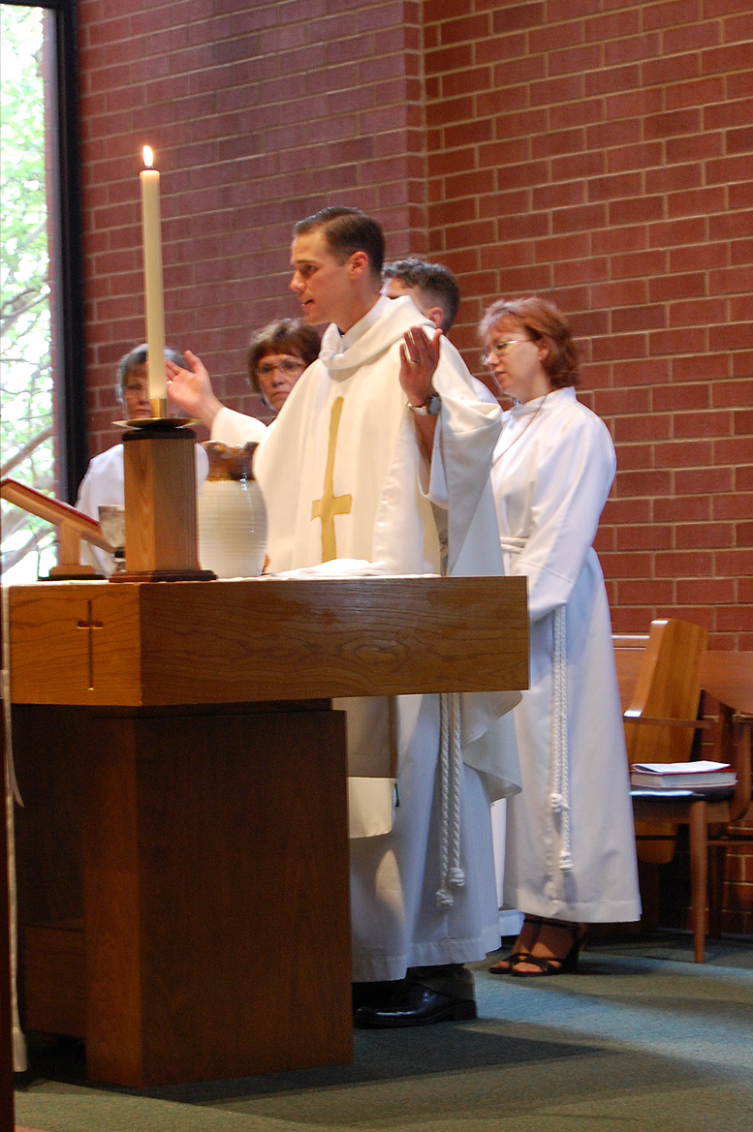

ASSISTING MINISTER

As Assisting Minister you will:
1. SING THE KYRIE
2. LEAD THE CREED
3. LEAD THE PRAYERS OF THE FAITHFUL
4. LEAD THE OFFERTORY PRAYER
5. ASSIST IN DISTRIBUTION OF HOLY COMMUNION
6. PRAY THE POST-COMMUNION PRAYER
7. SPEAK THE SENDING (“Go in Peace, Serve the Lord”)

Sometimes the Assisting Minister doubles as the Crucifer,
generally this is the case always at the 9:30 service.

BEFORE THE DAY

- Be sure to practice singing the Kyrie.

Kyrie Eleison is Greek for “Lord, Have Mercy”.
- Several musical versions of the Kyrie are used -- depending on the season of the church year.
- To help you practice, the written music and a recording of the music are on line at the Calvary website (www.godshearthumanhands.org).
- A CD is also available – just as Viktor for one.

The church musicians are also happy to rehearse with you.

To arrange a rehearsal:

Viktor may be contacted: viktorandersson@hotmail.com

817-284-8724 ext. 33.

Debbie may be contacted: dvillav123@charter.net

817-739-8611

Viktor & Debbie also available before the service if you would like a quick morning “refresher”.

DAY OF SERVICE
Try to arrive at least fifteen (15) minutes before the service.
- Preview the Prayers of the Faithful, by looking
in the altar book.
- These prayers are written by the pastors for that particular Sunday.
- Note especially names in the prayers. If you need help pronouncing any names, ask one of the pastors.
- Be sure to read through all of the prayers before the service.
- Vest
Your vestments are:
- White alb (that’s the name of the white robe)
- A rope cincture (belt)
- A cross.
Locate a white alb that fits comfortably & that hangs down to
the to of your shoes.A robe that is too long can be “cinched up”
using the rope cincture. Better too long than too short.
NOTE: All the worship leaders gather for prayer in the
robbing room before the service.

PROCESSION
Generally there will be a crucifer and acolyte who will lead the procession. Wait until the people start singing the processional hymn and then follow the acolyte up the aisle, walking to the left of the Lector. Pause at the steps until the candles are lit, then step up toward the altar. When you reach the altar, you may bow before it & then walk around to left of the altar. Your sitting place is usually left of the two innermost chairs. Sometimes you will double as crucifer. If this is the case, you lead the procession. Wait for the congregation to start singing the processional hymn and then move slowly up the aisle with the cross lifted high. Place the cross into its holder (usually directly behind the altar between chairs). NOTE: The crucifix is used in Advent & Lent, the cross during other Sundays.
1. SING THE KYRIE

The Presiding Minister begins the liturgy with the Apostolic Greeting:
P: The grace of our Lord Jesus Christ, the love of God, and the communion of the Holy Spirit be with you all.
We respond: And also with you.
- During this greeting, make your way to the pastor’s side, being
ready to sing the Kyrie, which begins immediately after our response. Sing the Kyrie with your hands uplifted – about shoulder height.
When finished, return to your place behind the altar.
2. LEAD THE CREED
During the last verse of the Hymn of the Day after the Sermon, ease
forward so you're at the altar book to lead the Creed.
After asking the congregation to “join in professing our faith using the
(Apostles’ or Nicene) Creed”, lead the reading of it, speaking loudly
at a deliberate pace – Remember you are LEADING …
NOTE: When there is a Baptism, the Creed is part of the
Baptismal Rite.

3. LEAD THE PRAYERS OF THE FAITHFUL
NOTE: When there is a Baptism, the Prayers of the Faithful are part of the Baptismal Rite,
- Immediately after the Creed, you will start the Prayers of the Faithful.
- You read a petition, concluding with the phrase "Lord in your mercy," which prompts the congregation to respond "Hear our prayer."
As a general rule: whenever you say: “let us pray….” place your hands
together in front of you. When you commence the main part of the
prayer, raise your arms up to shoulder height.
Share the Peace. Once the prayers are concluded, exchange the Peace with the other Worship Leaders, then continue to do so with the congregation. NOTE: You might bring the offering plates to the ushers, if the acolyte/crucifer does not do this.
4. LEAD THE OFFERTORY PRAYER
After the sharing of the peace, the offering is collected and the communion elements are brought forward. Again, ease your way up to the pastor’s side. Once the communion elements have been placed on the altar and the pastor is finished preparing them, lead the offertory prayer, hands uplifted, then stand back, participating in the liturgy until the Presiding Minister communes you.

5. ASSIST IN DISTRIBUTION OF HOLY COMMUNION
The Worship Leaders receive communion first.
You may be handed the chalice to commune the other Worship Leaders. If not, after you receive communion, take one of the chalices and its accompanying cloth (called a “Purificator”) and wait to follow the person distributing the bread on your side.
NOTE: Though rare, you might distribute the bread. If you are distributing the bread, proceed to your side, breaking off a portion and placing it in the person’s hands, saying: “THE BODY OF CHRIST”
Usually you will be distributing the chalice. You will follow along with the chalice and the cloth to offer it to each of the communicants at the rail. Take your cue from the communicant – if they reach for the chalice, keep hold of the chalice while still letting him or her guide the chalice to their mouth and say “THE BLOOD OF CHRIST” – if they don’t reach for the chalice, they will be waiting for individual glasses. Move on to the next person.
  - Wipe the rim of the chalice with the cloth each time someone drinks from it and turn the chalice slightly.
  - If the chalice runs low on wine go to the altar and fill it back up to roughly 1/3 capacity, then return to your place in the rotation. The Communion Assistants will wait for you.
Finish with communion. Carry the chalice and cloth into the back room adjacent to the sanctuary (the “Sacristy”) and set them on the counter next to the sink.

6. PRAY THE POST-COMMUNION PRAYER

Return to your place behind the altar and join in singing the last communion hymn.
Once we begin singing the Post-Communion Canticle, ease back up to the altar to say the Post-Communion prayer. (Hands together for: “Let us Pray”; hands uplifted for the prayer) Step back.
Now the Pastor blesses the congregation with the Benediction.

RECESSION

When the acolyte and crucifer process out, follow them around the altar and down the aisle side-by-side with the Lector. When you reach the back of the sanctuary, remain inside, singing the recessional hymn.
NOTE: If you’re doubling as the crucifer, look to the Presiding minister for a cue as to when to take up the cross and begin. If it's a short hymn, you may need to step off immediately. If it's a long one, the Presiding minister may hold you for a few verses. When you reach the back of the sanctuary, stop short of the balcony, and turn to face the congregation, holding the processional cross high aloft.

7. SPEAK THE SENDING

  - At the conclusion of the recessional hymn,
say loudly and joyfully:
"GO IN PEACE, SERVE THE LORD,"
The Congregation responds "Thanks be to God."
Greet the people as they depart. If you have the cross, return it to the robbing room, then return to greet the people.

